1- Abstract class

* is the class that contain one or more than one abstract method (methods without implementation)
* to declare an abstract class we make use of the***abstract***keyword
* a class declared abstract may or may not include abstract methods but if it includes an abstract method then it must be an abstract class
* Ex:   
  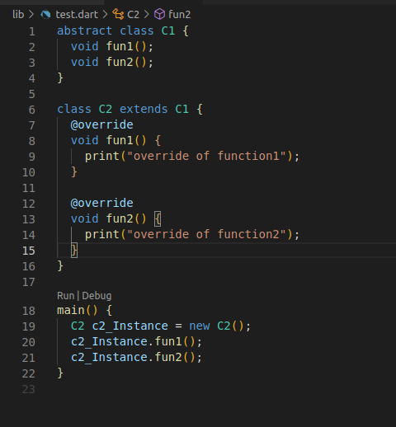

—-----------------------------------------------------------------------------------

2- Static

* “static” is a keyword that can be used to define class members (variables and methods) that belong to the class itself rather than to instances of the class.  
  a) Static Variables:
* static variables are declared using the “static” keyword within a class.
* They are shared among all instances of the class.
* Static variables are initialized only once and retain their values across multiple instances.
* They can be accessed using the class name itself, without creating an instance.
* Ex

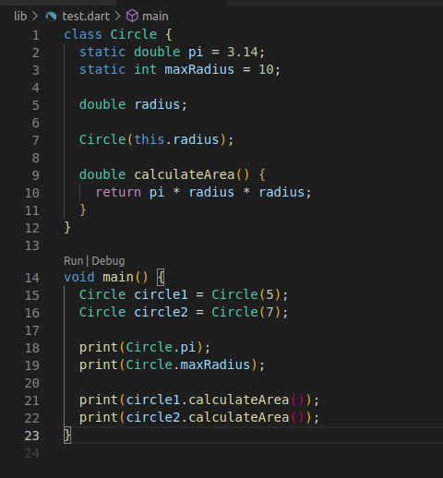

b) Static Methods:

* Static methods belong to the class itself, rather than the instances of the class.
* They can be called without creating an instance of the class.
* Static methods are useful for performing operations or computations that are not specific to any particular instance.

—---------------------------------------------------------------------------------------

3- Encapsulation:

* Encapsulation means hiding data within a library, preventing it from outside factors. It helps you control your program and prevent it from becoming too complicated.
* To Achieve Encapsulation In Dart :
* Declaring the class properties as private by using underscore(_).
* Providing public getter and setter methods to access and update the value of private property.
* Ex:   
  